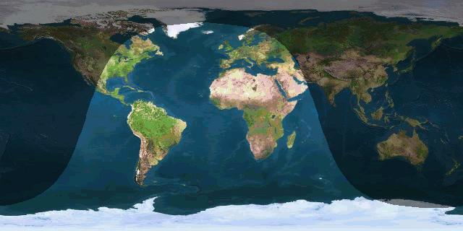

Grayline – May 13, 2013 @ 1200 UTC

